# PROGRAMMABLE PERISTALTIC PUMP

1. **INTRODUCTION :**

MuRhoPye Programmable Peristaltic Pump has seal less design so the problem of corrosion is eliminated since the fluid does not come in contact with any metal part. A peristaltic pump can run even when there is air gap in the tube i.e. it supports dry running. Pump provides a user friendly interface which allows user to easily select different options, navigate between screens and give input to the system in a very interactive way with graphics displayed on a graphical LCD display. The peristaltic pump also has features like calibration which allows user to correct the accuracy of the pump and provide very accurate control of volume of liquid dispensed by the pump. The direction of pumping action is reversible.

* 1. **Positioning the pump:**

The Peristaltic pump is to be placed at a location based on availability of utilities such as power supply and process consideration. For ease of movement and operation the pump heat is located in the front and power supply is located at the back of the pump.

* 1. **Connecting/ Replacing the Silicon tubing:**
* Unscrew the bolt till the tubing is held loosely by tube holders.
* Slightly pull out the top tube holder.
* Turn the pressure adjuster clockwise to about 90 degree.
* Push the shoe to the top and gently take out the tubing.
* To replace the tube gently place it on top of the rollers on the Head and position it through the tube holders.
* Turn the pressure adjuster to the original position and if necessary adjust the screw on top till the required pressure is applied on the shoe.
* Tighten the bolt of the tub holder so as to clamp the tube tightly.
* Ensure that tightening this bolt does not deform the tube.
  1. **Installation and Startup:**
* Connect the utilities (Foot switch, Pump head, Tube) to the pump.
* Install the connection between PC and Pump.
* Connect the pump to mains.
* Switch on the mains. Switch on the power switch.
* Within few seconds, the LCD will display the logo of MuRhoPye followed by various icons. Now the pump is ready for operation.

**2. Features:**

* **Memory Retention:**

When peristaltic pump is under operation and if there is a power out, the pump will retain information about its present operation. When the power is back, the pump requires attention from operator to dispose of the interrupted dose and place the sink back in place and respond to pumps query which is shown in figure 2.1.

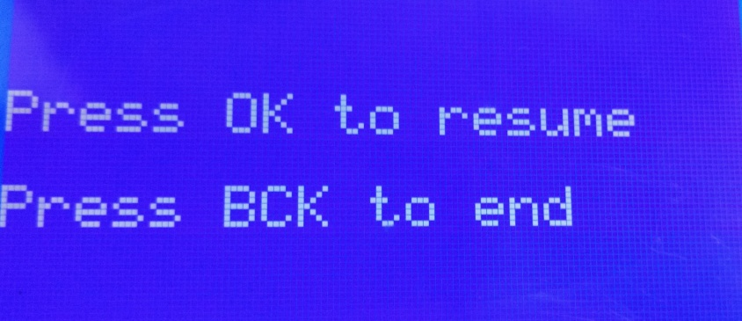

**Fig 2.1: Query screen**

The operator can choose to either continue the task that was interrupted by the power out by pressing “**OK**” keyor choose to start a new task by terminating previous by pressing ”**BACK**” key.

* **Calibration:**

One of the important features of this pump its ability to calibrate itself easily. It has a built in calibration option which requires the operator to enter the volume of the liquid dispensed in a pre calibrated jar, based on which the pump will be calibrated for Foot switch mode of operation.

Further the pump also has a custom calibration option for each dose which asks the operator to enter the dispensed volume at the specified rate, based on which the speed of pump will be altered.

* **Interactive GUI:**

The peristaltic pump comes with large LCD (128×64) and colored membrane keypad with 21 keys. There are dedicated navigation keys in addition to the numeric keys. The GUI consists of graphical icons and navigational effects in order to improve ease of aces of pump.

* **Buzzer:**

The peristaltic pump is equipped with a buzzer which is used to alert the operator after the completion of the task. The buzzer blows for 5 seconds once a task is complete. It should be noted that the pump will not respond to any key press until the buzzer is off again.

* **Serial Communication interface:**

The pump is capable of communicating with other devices through serial communication. It can be remotely controlled by PC by using the application provided along with this pump. It can also be interfaced with electronic weight balance for weight based dispensing operations.

* **Profile Saving:**

If certain tasks are repeated regularly, it is convenient to save such profiles in order to avoid entering the parameters again and again. The pump supports 8 profiles in each mode to save, which can be directly accessed through saved profiles from the home screen

* **Emergency Stop:**

When unanticipated event occurs when a dose is in progress it is every much necessary to be able to stop the pump and continue the task from the point where it was interrupted. A dedicated colored “**STOP**” key is provided, in order to resume the process which was stopped use “**PRI/RES**” key.

* **Foot Switch compatibility:**

The pump is compatible with foot switch which improves the ease of access of pump in laboratory condition. The foot switch can be connected to pump through the connecting port provided and can be used in Foot switch mode of operation.

* **Data Logging:**

The peristaltic pump also has the data logging capability which is an important aspect of process validation. The pump has and integrated Real Time Clock and SD card slot. The real time clock unit provides information about present date and time which is used by the pump to write files into SD card by creating separate date folders each day as shown in figure 2.2

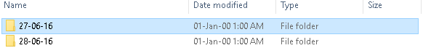

**Fig 2.2: Folders created by pump in SD card**

Each such folder created consists of text files which have the starting time of the process as its name. It is shown in figure 2.3.

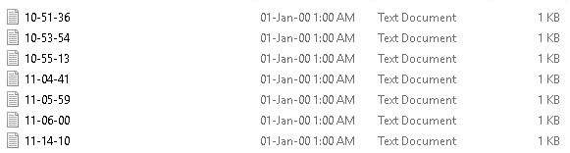

**Fig 2.3: Task Files inside each folder**

The text files consist of the parameters of the task performed and also the start time of each dose and the end time of each dose. The task performed without any interruption in power will contain a line “**All doses completed successfully**”. A sample text file is shown in figure 2.4

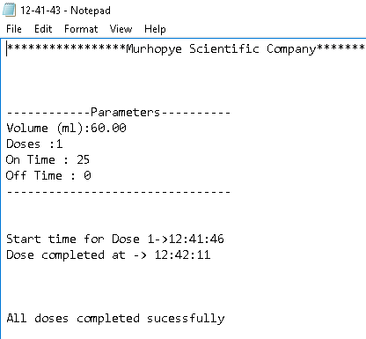

**Fig 2.5: Sample task text file**

* **Copy mode:**

Copy mode is one of the modes of operation using foot switch, it is used when the user does not know the exact volume to be dispense. In this mode the pump will start dispensing of liquid on first press of foot switch. The dispensing continues till the foot switch is pressed again. Once this is done the pump copies the amount of liquid to be dispensed and dispenses that quantity every time the foot switch is pressed after copy.

**3. Operation Modes:**

The initial screen to which the system loads into is home screen which has the options to select among various operational modes of the peristaltic pump as shown in figure 3. The user can use the matrix keypad provided with the pump to navigate amongst the modes using navigation keys (, <, ^, v). To enter specific modes use the “**OK**” button.

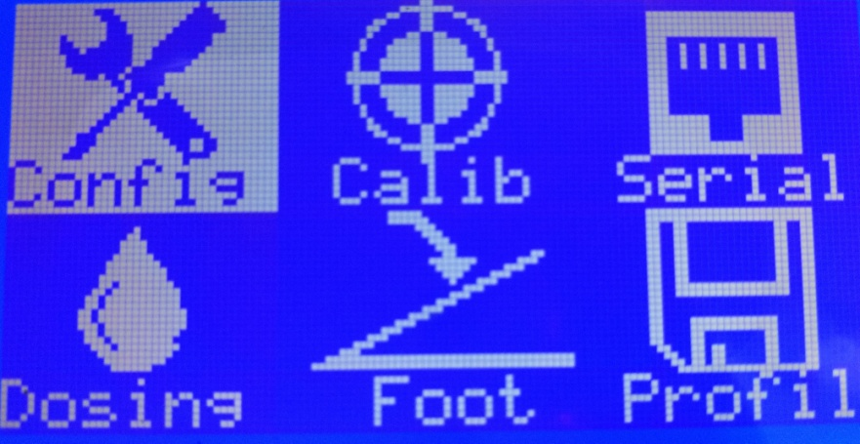

**Fig 3: Home Screen**

**3.1 Configuration mode:**

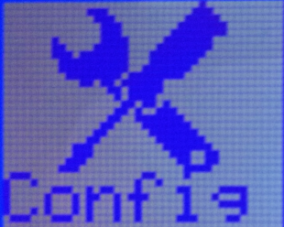

**Fig 3.1: Configuration icon**

On selection of configuration mode, system will display a new bitmap on GLCD which displays the option for selection of pump head and tube size from available list as shown in figure 3.1.1.To navigate among different options use navigational keys and select the suitable one with the help of “**OK**” key. GLCD screen depicting the choice for pump head is shown in figure 3.1.2. The system is programmed to configure itself based on the selected pump head and tube size for proper operation.

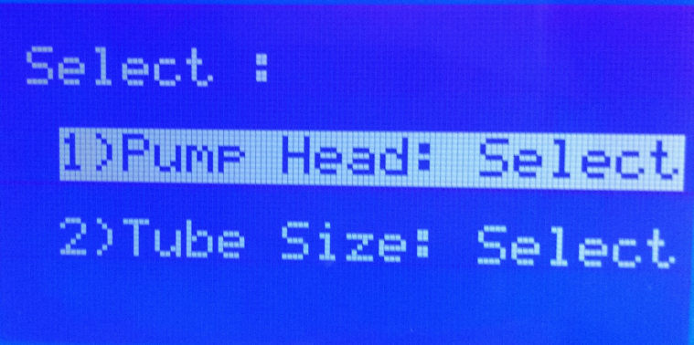

**Fig 3.1.1: Configuration mode selection options**

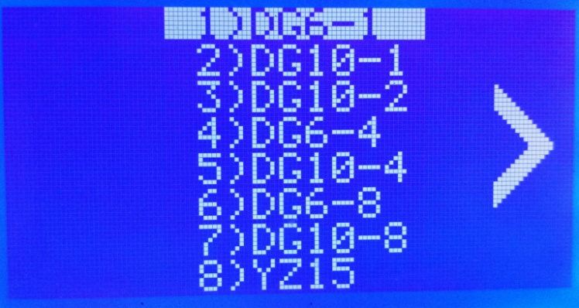

**Fig 3.1.2: Pump head selection menu**

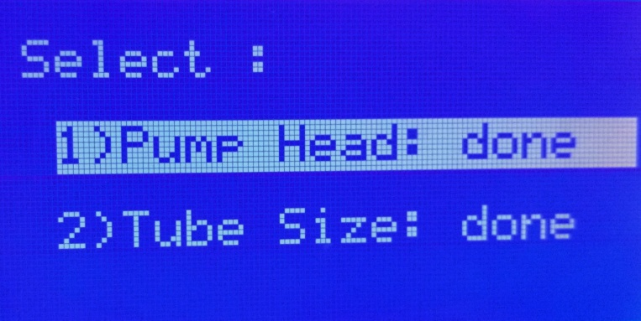

**Fig 3.1.3: Screen after configuration**

**3.2 Calibration mode:**



**Fig 3.2.1: Calibration icon**

To calibrate the pump manually, user first needs to enter the calibration mode, the user is asked to ensure the tube is completely filled with liquid before calibrating the pump. If the tube is not completely filled then use the “**PRI**” (priming) switch to fill the tube completely with liquid and ensure there are no air bubbles. After priming insert the source side of the tube to the jar containing liquid and place a pre calibrated measuring jar at the sink side of the tube. Press “**OK**” key to start the calibration process, after dispensing is completed the system prompts to enter actual volume dispensed. Enter the volume collected in the calibrated jar. System is programmed to calibrate its internal parameters based on the error value and mode of operation. After this the pump is said to be calibrated for 120 RPM (ideal speed) of operation for Foot Switch mode.

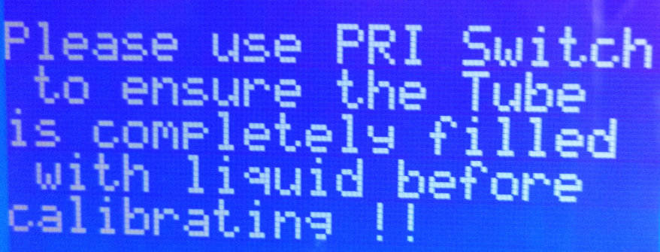

**Fig 3.2.2: Warning to ensure Priming before calibration**

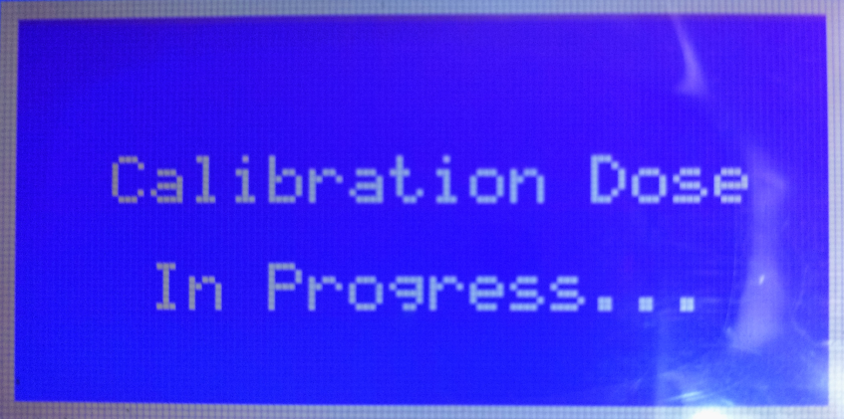

**Fig 3.2.3: Display when calibration dose is under progress**

**3.3 Serial Communication Mode:**

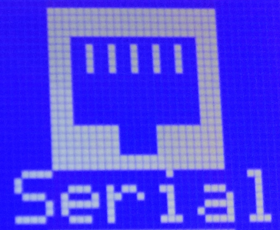

**Fig 3.3.1: Serial Communication icon**

One of the special features of this pump is its serial interface with RS232.The pump has two options to choose from in Serial Com Mode, namely:

1. Weight Balance Mode
2. PC Control Mode

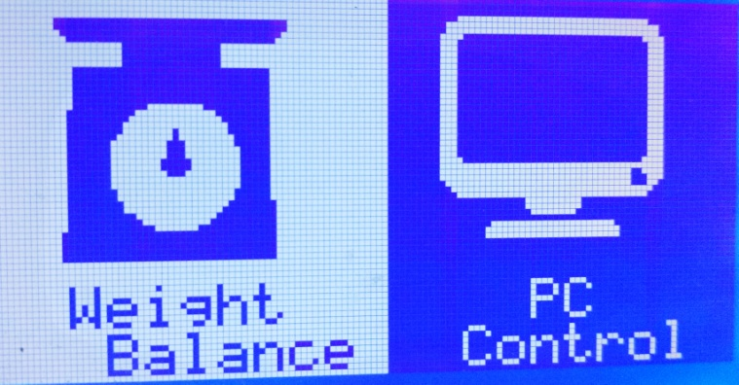

**Fig 3.3.2: Serial communication mode selection screen**

**3.3.1 Weight Balance Mode:**

The pump can be connected to a electronic weighing balance with RS232 port whose weight reading serve as a feed back for the pump. On entering the weight balance mode the user has to enter the weight of the liquid to be dispensed using the keypad and press ”**OK**” key, then the user is asked to press any key to start dispensing the liquid. The pump rotates at 120RPM until the dispensed liquid weight is 5 gram less than the required weight. Once it approaches close to required weight the speed of pump reduces to 60 RPM. The weight of the liquid dispensed is continuously displayed on the display.

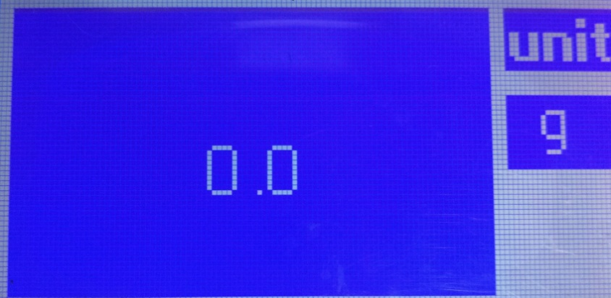

**Fig 3.3.1.1: Input screen of weight balance mode**

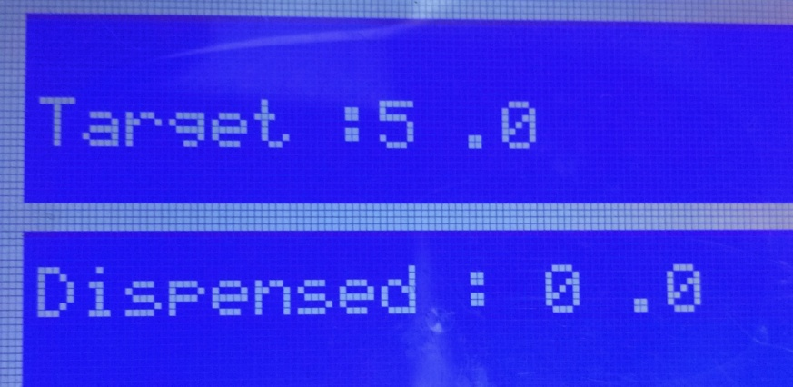

**Fig 3.3.1.2: Liquid Dispensing screen in weight balance mode**

**3.3.2 PC Control Mode:**

The pump can be connected to a PC through USB cable (type A to type B). This provides remote monitoring of the pump through PC application.

**Steps for connecting PC to Pump:**

* Ensure the pump is connected to PC through provided cable.
* Launch the provided application for pump control on PC.
* Check the Comp port box in application if it has any Com port name in it, Ensure the pump is connected to the same COM port using the Device manager (for Windows PC) else enter the correct COM port name in the provided text box.
* Press the “**Connect**” button.
* The pump will restart do not panic allow it to load the icons then navigate to Serial Comm. Mode. Select PC Control Mode. Now the pump is configured for PC control.
* Specify the required parameters in the application like flow rate, on time, off time, number of doses and direction of pumping.
* Press the “**Start**” button. The parameters in “**Dose in progress**” panel will be automatically updated.
* If anything goes wrong use the “**Stop**” button provide in the application to stop the pump or use the power switch on the pump.
* To resume the operation press “**Start**” button.

Once the process is complete if you wish to come out of PC control press “**BCK**” key in the pump, in the mean time the application on PC can also be closed.

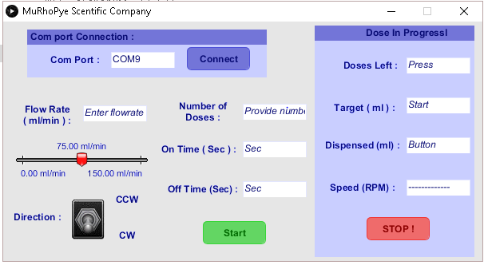

**Fig 3.3.2.1: Computer application for pump control**

**3.4 Dosing Mode:**

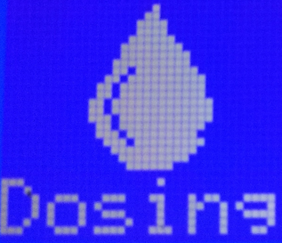

**Fig 3.4: Dosing icon**

User can navigate into dosing mode from the home screen, system provides the user with two option, namely:

1. Volume based operation
2. Flow Rate based operation

The display screen for the same is shown in figure 3.4.1

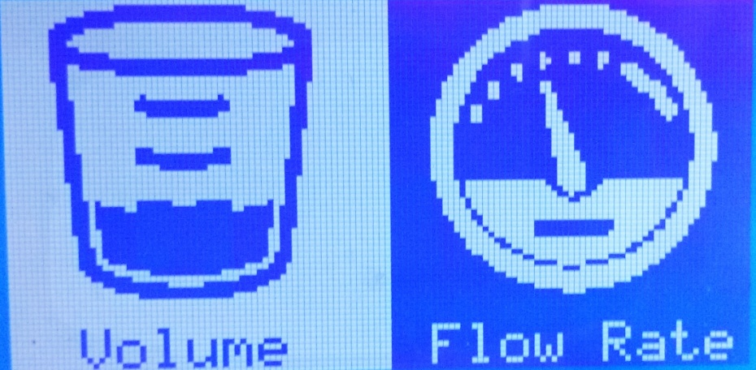

**Fig 3.4.1: Dosing mode menu**

**3.4.1 Volume Based Operations:**

Volume based mode of operation will display a new screen where is user is prompted to enter different inputs to the system. For volume based operations the inputs consists of volume to be dispensed in ml, number of doses, on time (Time in which the specified volume of liquid should be dispensed), off time (Time between two doses). Further a dosing profile can be saved using “Save” option. Once a profile is saved it can be accessed later from the “Saved Profile” mode. After providing all the required parameter for the pump select the “Start” option to start the process. The screen used for getting required inputs from user is shown in figure 3.4.1.1.

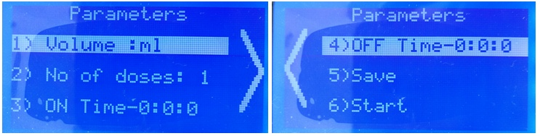

**Fig 3.4.1.1: Volume based operation menu.**

Use the navigation keys to navigate among various options and “**OK**” key to enter into a particular option. Use “**BCK**” key to return to previous screen.

When user selects an option to enter any numeric value another screen is displayed where the number entered by the user is shown on LCD for visual confirmation. This screen is shown in figure 3.4.1.2.



**Fig 3.4.1.2: Screen to enter numerical value of volume to be dispensed.**

This screen is an input screen for volume parameter. Use the numeric keys on keypad to provide the inputs incase of float inputs use the “**.**” key to indicate decimal pointer. Use “**C**” key to clear the entry if you want to clear the input. Once the values is entered use “**OK**” key to confirm the value.

**3.4.2 Flow Rate Based Operations:**

Flow Rate based mode of operation will display a new screen where is user is prompted to enter different inputs to the system. For Flow Rate based operations the inputs consists of Flow Rate of Liquid to be dispensed in ml/min , number of doses, on time (Time for which the liquid should be dispensed at the specified Flow Rate), off time (Time between two doses). Further a dosing profile can be saved using “**Save**” option. Once a profile is saved it can be accessed later from the “Saved Profile” mode. After providing all the required parameter for the pump select the “**Start**” option to start the process. The screen used for getting required inputs from user is shown in figure 3.4.2.1

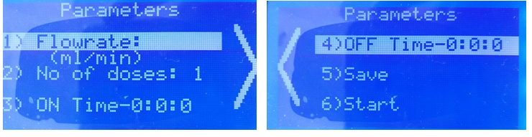

**Fig 3.4.2.1: Flow-rate based operation menu.**

**3.5 Foot Switch mode:**



**Fig: 3.5: Foot Switch icon**

When user navigates into foot switch mode from the home screen, system provides the user with option to select either copy operation mode or only foot switch based operation. The display screen for the same is shown in figure 3.5.1.

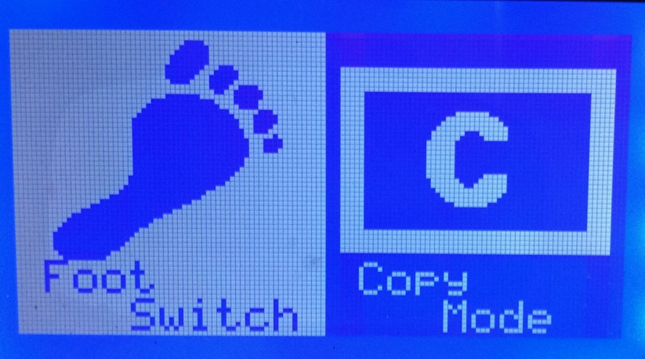

**Fig 3.5.1: Foot switch selection menu**

Upon selection of foot switch mode a screen as shown in figure 3.5.2 is displayed to prompt user to enter the volume to be dispensed per dose and to start the operation. Once the operation is started the control is entirely given to foot switch and click of foot switch triggers dispensing of the fluid volume corresponding to one dose.

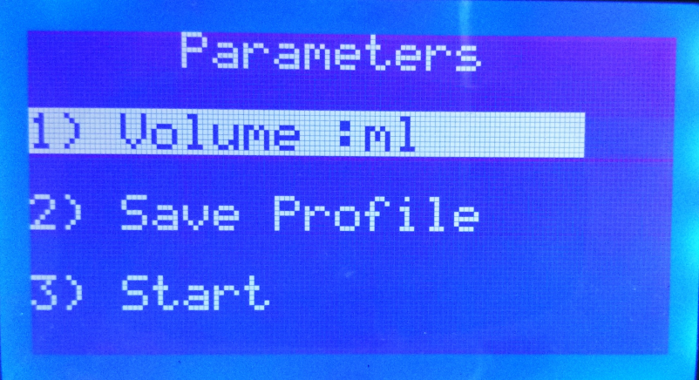

**Fig 3.5.2: Foot switch mode operation menu**

The profile save option will display a screen where user can navigates through various saved profiles of different operational modes. Upon selecting a particular profile user will be able to see the details about various values in that profiles and then will be prompted to load that profile or go back and select another profile.

Upon selection of copy mode the screen corresponding to figure 3.5.3 will appear, the user should use the footswitch to start dispensing of liquid and in order to stop the dispensing of liquid the footswitch has to be pressed again. The pump will store the time elapsed between these footswitch press and use it to dispense required quantity of liquid every time the footswitch is pressed. The user can exit out of copy mode using the “**BACK**” key or choose to dispense liquid by pressing footswitch again.

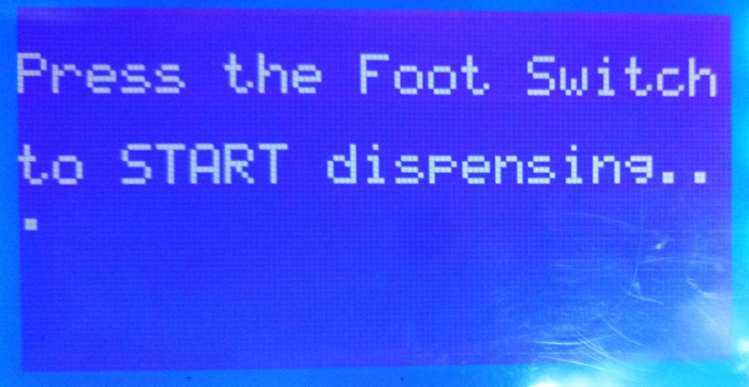

**Fig 3.5.3: Copy mode operation screen**

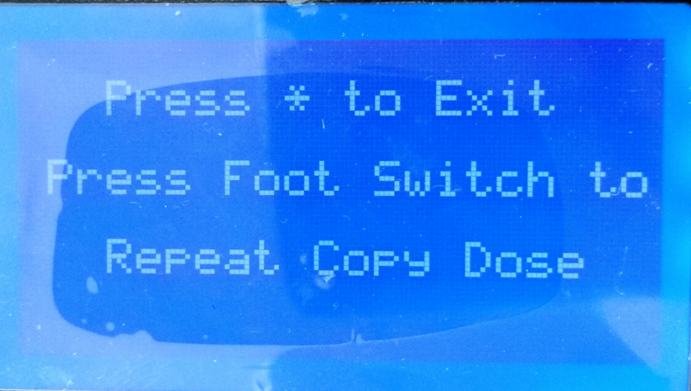

**Fig 3.5.4: Repeat copy mode screen**

**3.6 Saved Profiles:**



**Fig 3.6: Saved Profile icon**

When user navigates into saved profiles from the home screen, system provides the user with option to select either dosing mode based profiles or foot switch mode based profiles. The display screen for the same is shown in figure 3.6.1.

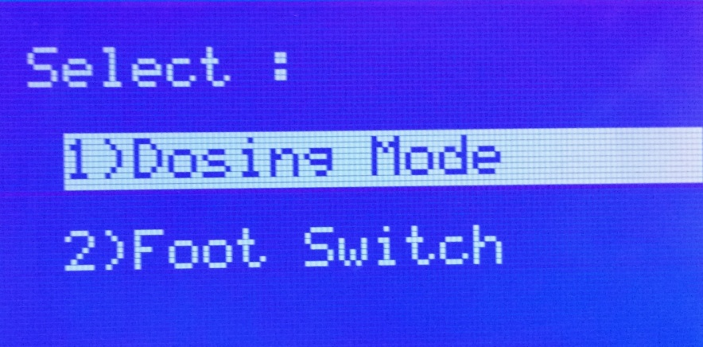

**Fig 3.6.1: Menu for Saved Profiles**

For selection of option use “**OK”** key and to navigate among the options use the navigation keypad provided. On selection of dosing mode the user will be provided with further options like volume based profiles or flow rate based profile as shown in figure 3.6.2. However on Foot switch mode selection no such option will be provided, the list of stored profiles will be displayed as shown in figure 3.6.3. Each mode store 8 profiles making total profiles that can be stored to 24 profiles.

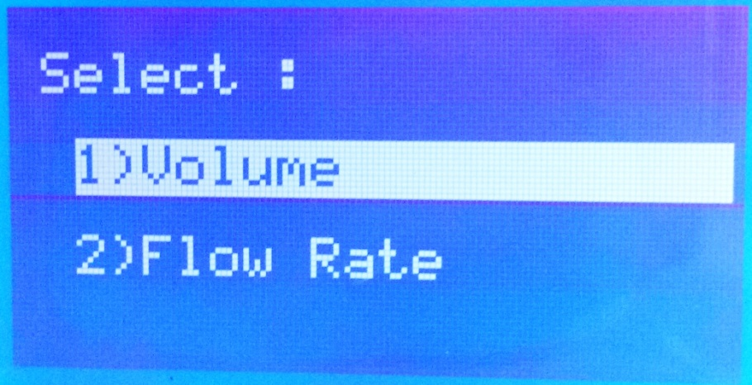

**Fig 3.6.2: Options under Dosing Mode**

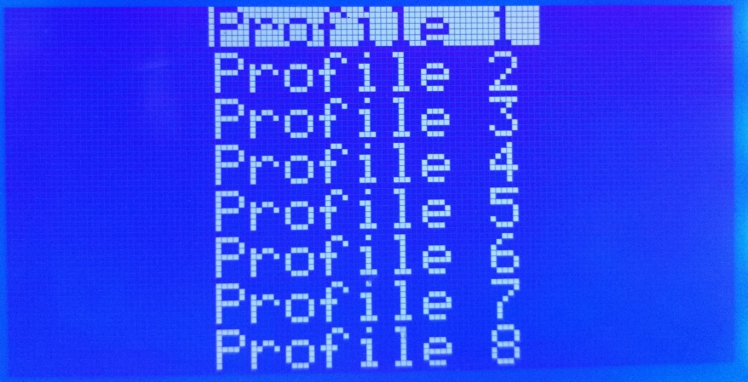

**Fig 3.6.3: List of Saved Profiles**

Once the list of profiles is displayed use the navigation keys to navigate amongst the profiles and use the “**OK**” key to select a particular profile. The parameter of the selected profile will be displayed as shown in figure 3.6.4. The user should confirm loading profile operation by pressing “**OK**” key. If the user wants to select a different profile use “**BACK**” key to go to previous screen.

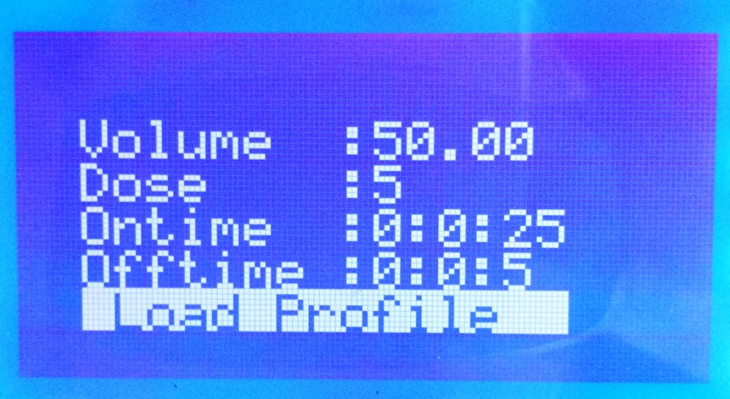

**Fig 3.6.4: Parameters of a Profile.**

**4. Trouble Shooting:**

* If anything goes wrong during dispensing of the liquid use “**STOP**” key to terminate the process. In order to resume back the operation of the pump restart the pump using the power switch.
* If the display is struck at a specific screen and if the pump fails to respond to any key press, restart the system by using power switch.
* While using PC control of pump ensure the pump is connected to PC, once the connection is established the pump will restart itself indicating the connection with PC was successful. If the pump does not restart then it means that the pump was not connected properly. Re-enter the com port number to which the pump is connected to and then click on “**CONNECT**” button on pc application.